**Music Analytics Week 10: Transcription using Sonic Visualizer**

The original composition for “Lavender Town”, was transcribed myself through sheet music found on MuseScore (MS). We can see the notation for the original composition below:

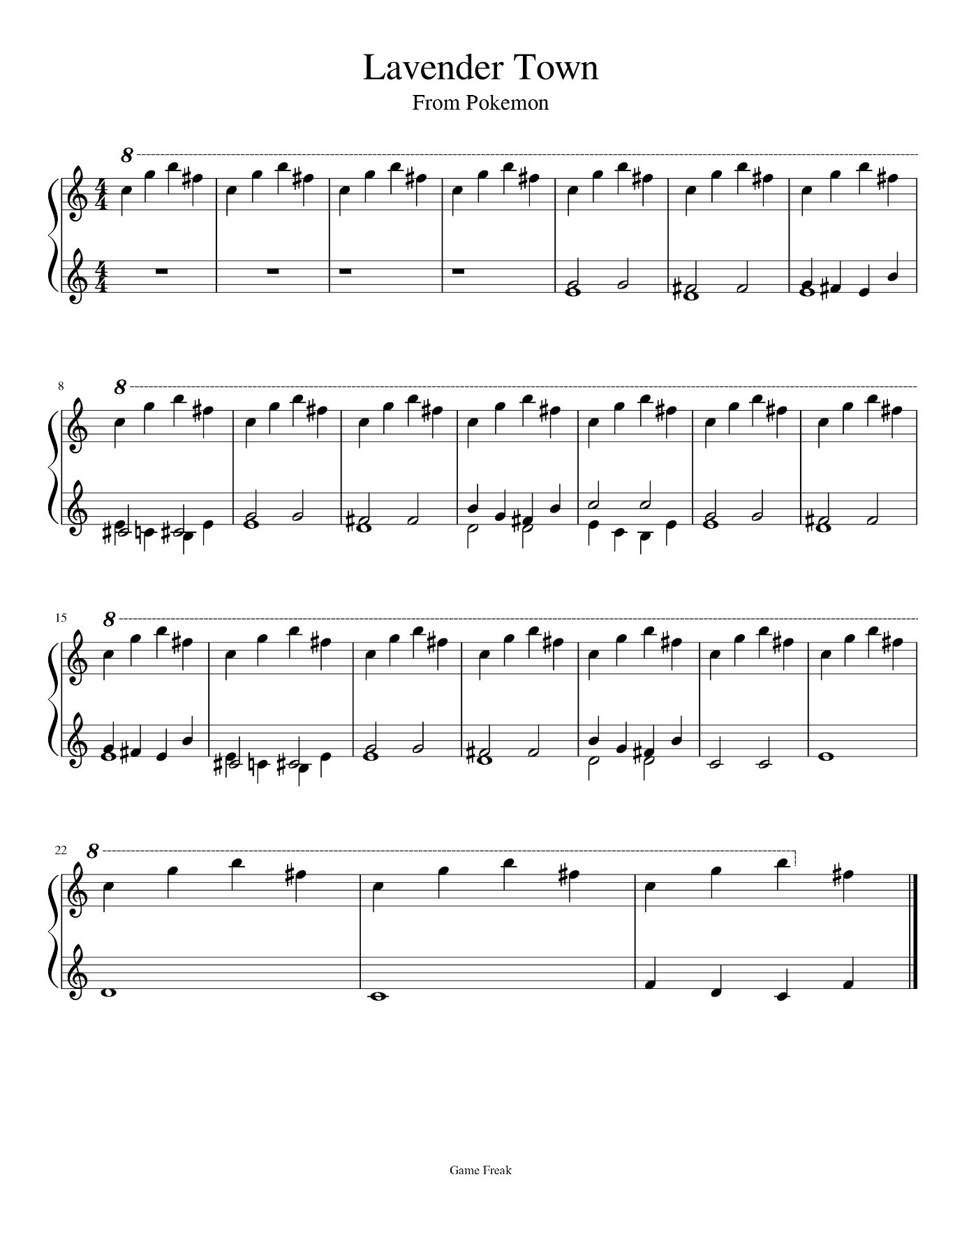

After exporting this as MIDI and transcribing it into a piano roll through SonicVisualizer (SV), the exported annotation pane appears in MuseScore as below: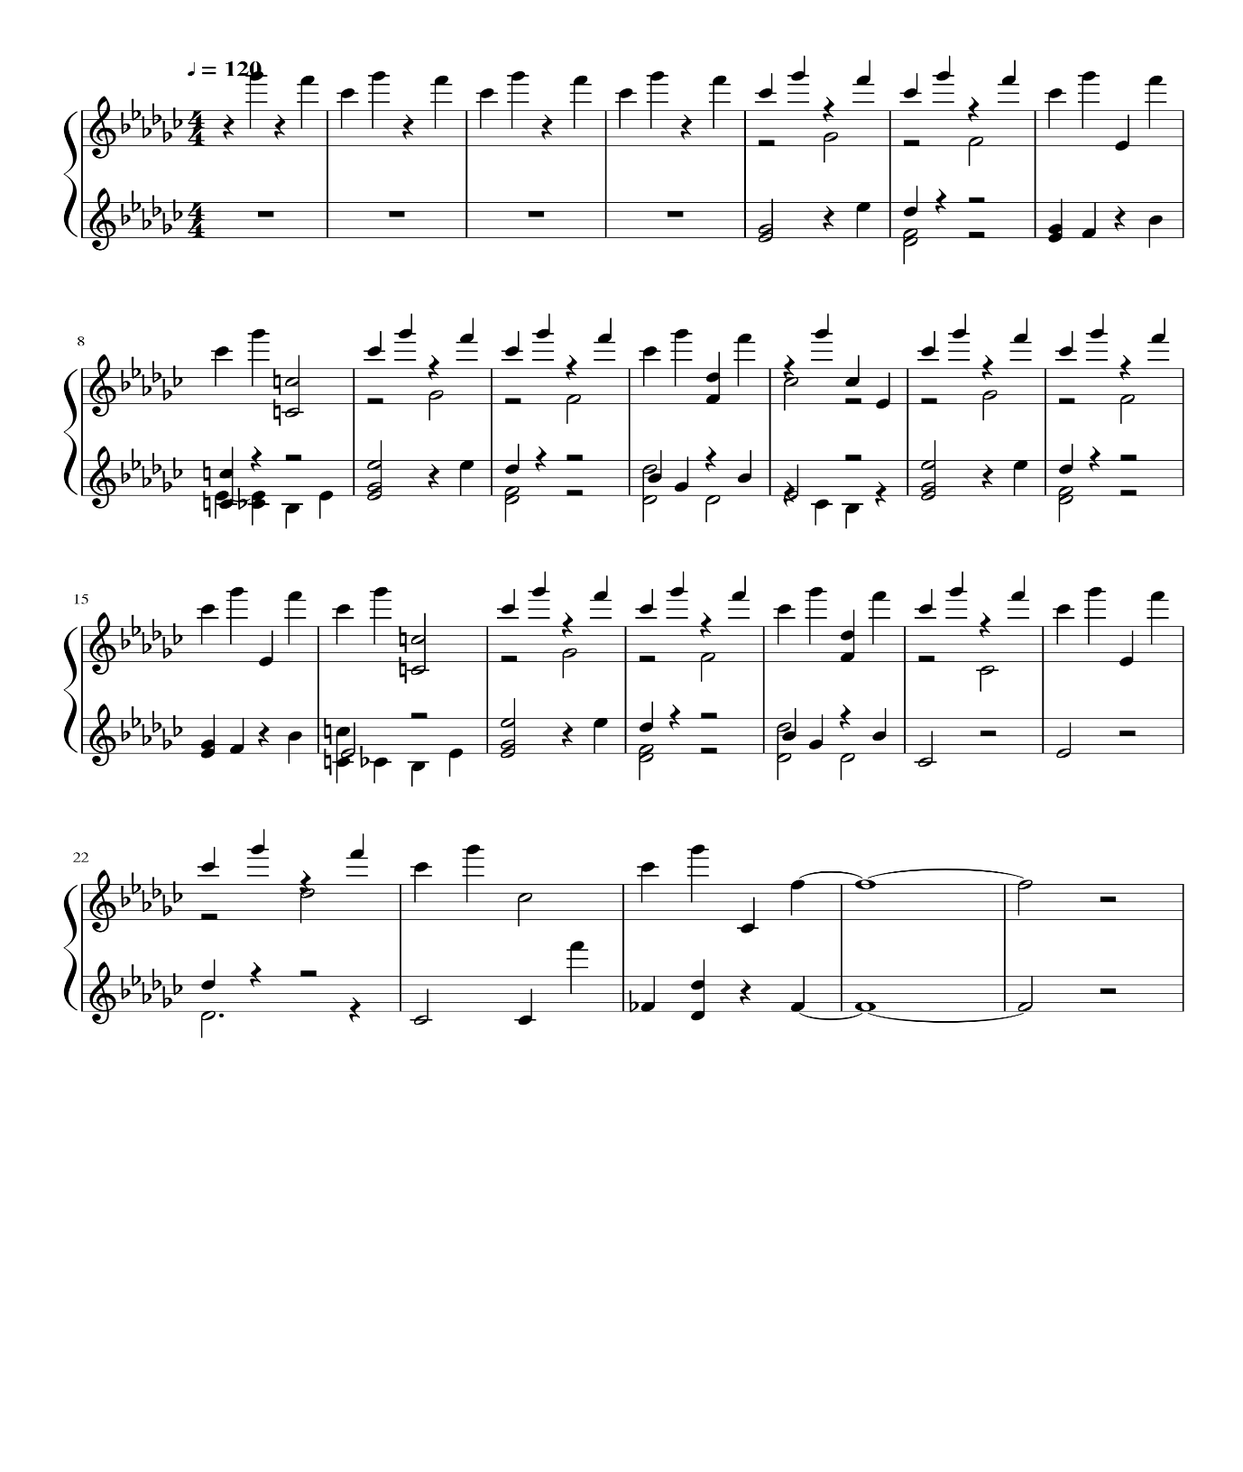

Comparing this to the original composition, it is apparent that:

* The SV transcription removes the ottava present in the original file; instead placing the notes higher on the staffs in order to replicate the higher pitch sound from the original.
* While the original composition has no distinct Key signature, the SV transcription has added **G Major** Key signatures to each measure of the track.
* The SV transcription has added in multiple rest notes, which were not present in original composition.
* The SV transcription includes multiple connecting ties between notes

When played back however, these differences are negligible to the human ear as the composition remains acoustically the same. Therefore, I can confidently say that the Sonic Visualiser transcribed the track with a high degree of accuracy; if sacrificing the notational structure.